**Spring Core and Maven**

**Exercise 1: Configuring a Basic Spring Application**

**Pom.xml (Library management)**

<project *xmlns*="http://maven.apache.org/POM/4.0.0"  
 *xmlns:xsi*="http://www.w3.org/2001/XMLSchema-instance"  
 *xsi:schemaLocation*="http://maven.apache.org/POM/4.0.0  
 http://maven.apache.org/xsd/maven-4.0.0.xsd">  
 <modelVersion>4.0.0</modelVersion>  
  
 <groupId>com.library</groupId>  
 <artifactId>LibraryManagement</artifactId>  
 <version>1.0-SNAPSHOT</version>  
  
 <dependencies>  
 *<!-- Spring Core Dependency -->* <dependency>  
 <groupId>org.springframework</groupId>  
 <artifactId>spring-context</artifactId>  
 <version>5.3.31</version>  
 </dependency>  
 </dependencies>  
</project>

**ApplicationContent.xml**

<?*xml version*="1.0" *encoding*="UTF-8"?>  
<beans *xmlns*="http://www.springframework.org/schema/beans"  
 *xmlns:xsi*="http://www.w3.org/2001/XMLSchema-instance"  
 *xsi:schemaLocation*="  
 http://www.springframework.org/schema/beans  
 http://www.springframework.org/schema/beans/spring-beans.xsd">  
  
 *<!-- Define the BookRepository bean -->* <bean *id*="bookRepository" *class*="com.library.repository.BookRepository"/>  
  
 *<!-- Define the BookService bean and inject BookRepository -->* <bean *id*="bookService" *class*="com.library.service.BookService">  
 <property *name*="bookRepository" *ref*="bookRepository"/>  
 </bean>  
  
</beans>

**BookRepository.java**

*package* com.library.repository;  
  
*public class* BookRepository {  
 *public void* saveBook(String bookName) {  
 System.***out***.println("Book \"" + bookName + "\" saved to the repository.");  
 }  
}

**BookService.java**

*package* com.library.service;  
  
*import* com.library.repository.BookRepository;  
  
*public class* BookService {  
  
 *private* BookRepository bookRepository;  
  
 *// Setter for Dependency Injection  
 public void* setBookRepository(BookRepository bookRepository) {  
 *this*.bookRepository = bookRepository;  
 }  
  
 *public void* addBook(String bookName) {  
 System.***out***.println("Adding book: " + bookName);  
 bookRepository.saveBook(bookName);  
 }  
}

**LibraryApp.java**

*package* com.library;  
  
*import* com.library.service.BookService;  
*import* org.springframework.context.*ApplicationContext*;  
*import* org.springframework.context.support.ClassPathXmlApplicationContext;  
  
*public class* LibraryApp {  
 *public static void* main(String[] args) {  
 *// Load the Spring configuration file  
 ApplicationContext* context = *new* ClassPathXmlApplicationContext(“applicationContext.xml”);  
  
 *// Get the BookService bean* BookService bookService = (BookService) context.getBean(“bookService”);  
  
 *// Use the service* bookService.addBook(“The Great Gatsby”);  
 }  
}

**Output:**

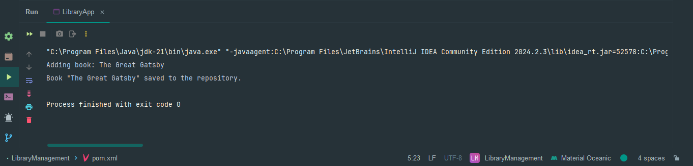

**Exercise 2: Implementing Dependency Injection**

**Pom.xml (Library management)**

<project *xmlns*="http://maven.apache.org/POM/4.0.0"  
 *xmlns:xsi*="http://www.w3.org/2001/XMLSchema-instance"  
 *xsi:schemaLocation*="http://maven.apache.org/POM/4.0.0  
 http://maven.apache.org/xsd/maven-4.0.0.xsd">  
 <modelVersion>4.0.0</modelVersion>  
  
 <groupId>com.library</groupId>  
 <artifactId>LibraryManagement</artifactId>  
 <version>1.0-SNAPSHOT</version>  
  
 <dependencies>  
 *<!-- Spring Core (safe patched version) -->* <dependency>  
 <groupId>org.springframework</groupId>  
 <artifactId>spring-context</artifactId>  
 <version>5.3.34</version>  
 </dependency>  
 </dependencies>  
  
 <build>  
 <plugins>  
 *<!-- Plugin to run main class -->* <plugin>  
 <groupId>org.codehaus.mojo</groupId>  
 <artifactId>exec-maven-plugin</artifactId>  
 <version>3.1.0</version>  
 <configuration>  
 <mainClass>com.library.LibraryApp</mainClass>  
 </configuration>  
 </plugin>  
 </plugins>  
 </build>  
</project>

**ApplicationContent.xml**

<?*xml version*="1.0" *encoding*="UTF-8"?>  
<beans *xmlns*="http://www.springframework.org/schema/beans"  
 *xmlns:xsi*="http://www.w3.org/2001/XMLSchema-instance"  
 *xsi:schemaLocation*="  
 http://www.springframework.org/schema/beans  
 http://www.springframework.org/schema/beans/spring-beans.xsd">  
  
 *<!-- Define BookRepository bean -->* <bean *id*="bookRepository" *class*="com.library.repository.BookRepository"/>  
  
 *<!-- Define BookService bean and inject BookRepository -->* <bean *id*="bookService" *class*="com.library.service.BookService">  
 <property *name*="bookRepository" *ref*="bookRepository"/>  
 </bean>  
  
</beans>

**BookRepository.java**

*package com.library.repository;  
  
public class BookRepository {  
 public void saveBook(String bookName) {  
 System.****out****.println("Book \"" + bookName + "\" saved to the repository.");  
 }  
}*

**BookService.java**

*package com.library.service;  
  
import com.library.repository.BookRepository;  
  
public class BookService {  
  
 private BookRepository bookRepository;  
  
 // Setter for dependency injection  
 public void setBookRepository(BookRepository bookRepository) {  
 this.bookRepository = bookRepository;  
 }  
  
 public void addBook(String bookName) {  
 System.****out****.println("Adding book: " + bookName);  
 bookRepository.saveBook(bookName);  
 }  
}*

**LibraryApp.java**

*package com.library;  
  
import com.library.service.BookService;  
import org.springframework.context.ApplicationContext;  
import org.springframework.context.support.ClassPathXmlApplicationContext;  
  
public class LibraryApp {  
 public static void main(String[] args) {  
 // Load Spring context from applicationContext.xml  
 ApplicationContext context = new ClassPathXmlApplicationContext("applicationContext.xml");  
  
 // Get the bookService bean  
 BookService bookService = (BookService) context.getBean("bookService");  
  
 // Test the dependency injection by calling addBook  
 bookService.addBook("To Kill a Mockingbird");  
 }  
}*

**Output:**

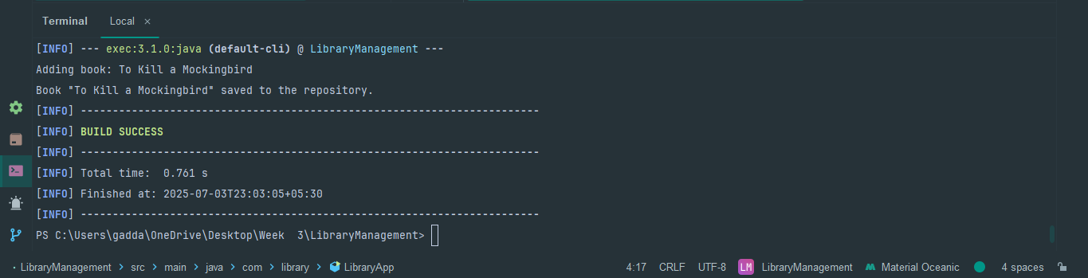

**Exercise 4: Creating and Configuring a Maven Project**

**Pom.xml**

<project *xmlns*="http://maven.apache.org/POM/4.0.0"  
 *xmlns:xsi*="http://www.w3.org/2001/XMLSchema-instance"  
 *xsi:schemaLocation*="http://maven.apache.org/POM/4.0.0  
 http://maven.apache.org/xsd/maven-4.0.0.xsd">  
 <modelVersion>4.0.0</modelVersion>  
  
 <groupId>com.library</groupId>  
 <artifactId>LibraryManagement</artifactId>  
 <version>1.0-SNAPSHOT</version>  
  
 <dependencies>  
 *<!-- ✅ Spring Context -->* <dependency>  
 <groupId>org.springframework</groupId>  
 <artifactId>spring-context</artifactId>  
 <version>6.1.6</version>  
 </dependency>  
  
 *<!-- ✅ Spring AOP -->* <dependency>  
 <groupId>org.springframework</groupId>  
 <artifactId>spring-aop</artifactId>  
 <version>6.1.6</version>  
 </dependency>  
  
 *<!-- ✅ Spring Web MVC -->* <dependency>  
 <groupId>org.springframework</groupId>  
 <artifactId>spring-webmvc</artifactId>  
 <version>6.1.6</version>  
 </dependency>  
 </dependencies>  
  
 <build>  
 <plugins>  
 *<!-- ✅ Maven Compiler Plugin with Java 21 -->* <plugin>  
 <groupId>org.apache.maven.plugins</groupId>  
 <artifactId>maven-compiler-plugin</artifactId>  
 <version>3.10.1</version>  
 <configuration>  
 <source>21</source>  
 <target>21</target>  
 </configuration>  
 </plugin>  
  
 *<!-- ✅ Exec Plugin to Run Main Class -->* <plugin>  
 <groupId>org.codehaus.mojo</groupId>  
 <artifactId>exec-maven-plugin</artifactId>  
 <version>3.1.0</version>  
 <configuration>  
 <mainClass>com.library.LibraryApp</mainClass>  
 </configuration>  
 </plugin>  
 </plugins>  
 </build>  
</project>

**Output:**

